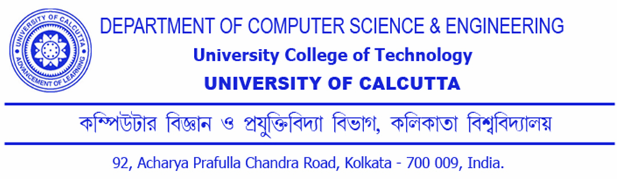

**CERTIFICATION**

This is to certify that the dissertation entitled “**Trust Based Security for Cloud Ecosystem”** is the bonafide work of **Prabal Kanti Naskar** and has been prepared according to the regulations for award of the degree of **Master of Technology** in **Computer Science and Engineering** in **University of Calcutta** for the year **2011** and the candidate has partially fulfilled the requirements for the submission of the dissertation.

**………………………………..…………….** Prof. Sunirmal Khatua Project Supervisor Comp. Sc. & Engg. Dept., CU

**……………………………………………….**  Prof. Nabendu Chaki Head of the Dept. Comp. Sc. & Engg. Dept., CU

………………………………………. ...…………………………………………

Mr. Sunirmal Khatua (Lecturer)

……………………………………….

**………………………….………………….** Prof. Sanjit Kumar Setua Project Supervisor Comp. Sc. & Engg. Dept., CU

Mr. Sanjit Kumar Setua (Reader)

Project Supervisor